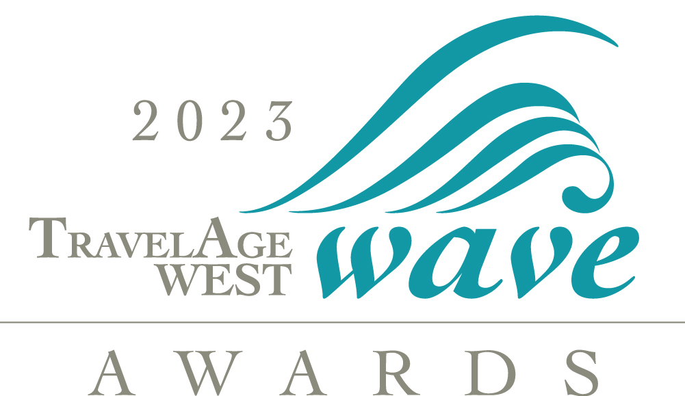

**PRESS RELEASE FOR IMMEDIATE MEDIA ATTENTION**

Contact: **[INSERT NAME]**

TEL:

E-MAIL:

**[COMPANY]** **RECOGNIZED WITH 2023 WAVE AWARD FROM *TravelAge West***

**DATELINE HERE** — **COMPANY** was honored with the 2023 WAVE Award in the category of **[name of category here]** on June 8 in Marina del Rey, California as part of the *TravelAge Wes*t WAVE Awards.

## LOS ANGELES — More than 190 companies, individuals and destinations were celebrated by the readers of TravelAge West as part of the WAVE Awards held June 8 in Marina del Rey, Calif., at The Ritz-Carlton, Marina del Rey. Honorees were recognized in 76 categories that included cruise, tour operator, airline, hotel and resort, destination, rail vacation and travel insurance companies. The annual awards give travel advisors the opportunity to recognize the outstanding qualities and services of their travel supplier partners.

In addition, top travel advisors were honored in four categories as part of the 2023 Trendsetters Awards, also presented at the gala. Categories included: Best Use of Social Media, Upward Bound Rock Star Advisor Under 40, Best Group Booking Effort and Best Targeted Marketing Idea.

More than 6,500 travel advisor professionals throughout the U.S. and readers of TravelAge West voted on the best-of-the-best from a list of Editor’s Pick award recipients that were chosen after careful review by Kenneth Shapiro, Publisher and Editor-in-Chief of *TravelAge West* and the editorial team of TravelAge West. Review methods included product analysis, on-site visits, a survey of a select group of industry advisors and online research.

“With travel booming post-pandemic, the WAVE Awards have taken on an even greater significance,” Shapiro said. “Travel advisors want to acknowledge the great travel companies that go above and beyond to take such good care of their customers as they once again travel the world.”

This year, *TravelAge West* once again awarded its Excellence in Leadership Award, which honors individuals who, in the course of their careers in travel and tourism, have consistently demonstrated leadership and insight, effected change or innovation and made extraordinary contributions to both organizations and the industry at large. The 2023 *TravelAge West* Excellence in Leadership Awards went to Michele Saegesser, Rodrigo Esponda Cascajares and Scott Koepf.

All of our Leadership Award winners show true dedication to the travel industry, helping to make their brands and organizations models for others to follow,” Shapiro said.

At the black-tie event, guests dined on a four-course meal while being treated to a multimedia presentation of the award recipients.

*TravelAge Wes*t will feature WAVE Awards coverage in the July 10 issue.

**[Insert quote here from your company representative.]**

* * * * * * * * *

**[Insert information about your company here]**.

*TravelAge West* ([www.travelagewest.com](http://www.travelagewest.com)) has been serving the travel industry for 53 years as a leading source of travel industry news and product information. For more information about *TravelAge West,* contact Lisa Frobisher at 310-954-2514 or lfrobisher@travelagewest.com.

For more information, visit **[Insert Company’s Web site here]** or call **[Insert Company’s phone number here]**.

* * * * * * * * *

2023 WAVE AWARDS

WAVE CATEGORIES & WINNERS

**AIR**

Best Airline Vacation Brand

**Delta Vacations**

Best Airline, Domestic

**Delta Air Lines**

Best Airline, International

**Air France**

Best International First/Business Class

**Emirates**

Best Airline Loyalty Program

**Delta Air Lines**

**CRUISE**

Cruise Line with the Highest Client Satisfaction (less than 1,300 passengers)

**Viking**

Cruise Line with the Highest Client Satisfaction (more than 1,300 passengers)

**Celebrity Cruises**

Cruise Line Providing the Best Travel Advisor Support (ocean-going)

**Royal Caribbean International**

Expedition Cruise Line Providing the Best Travel Advisor Support

**Silversea Cruises**

Small-Ship Cruise Line Providing the Best Travel Advisor Support

**Windstar Cruises**

Best New Ship (ocean-going)

**Wonder of the Seas, Royal Caribbean International**

Best New Expedition Ship

**Seabourn Venture, Seabourn Cruise Line**

Best Onboard Dining Venue

**Pink Agave, Virgin Voyages**

Best Cruise Line for Shows and Nightlife

**Royal Caribbean International**

Best Cruise Line for Families

**Carnival Cruise Line**

Best Cruise Line for Caribbean Sailings

**Royal Caribbean International**

Best Cruise Line for Alaska Sailings

**Princess Cruises**

Best Cruise Line for Antarctica Sailings

**Lindblad Expeditions - National Geographic**

Best Cruise Line Private Island

**CocoCay, Royal Caribbean International**

Best World Cruise

**Viking**

Best Cruise Line for Luxury

**Regent Seven Seas Cruises**

**RIVER CRUISE**

River Cruise Line With the Highest Client Satisfaction

**AmaWaterways**

River Cruise Line Providing the Best Travel Advisor Support

**Viking**

Best New River Cruise Ship

**Avalon View, Avalon Waterways**

Best River Cruise Line for U.S. Sailings

**Viking**

Best River Cruise Line for Families

**AmaWaterways**

Best River Cruise Line for Luxury

**AmaWaterways**

**RAIL**

Best Rail Vacation Provider

**Railbookers**

**TOUR OPERATOR**

Escorted Tour Operator Providing the Best Travel Advisor Support

**Globus Family of Brands**

FIT Tour Operator Providing the Best Travel Advisor Support

**Pleasant Holidays**

Best FIT Tour Operator, Europe

**Classic Vacations**

Best Escorted Tour Operator, Europe

**Globus Family of Brands**

Best Tour Operator, Africa

**Abercrombie & Kent**

Best Tour Operator, Asia

**Trafalgar**

Best Tour Operator, Australia/New Zealand/South Pacific

**Pleasant Holidays**

Best Tour Operator, Caribbean

**Funjet Vacations**

Best Tour Operator, Central/South America

**Globus Family of Brands**

Best Tour Operator, Hawaii

**Pleasant Holidays**

Best Tour Operator, Mexico

**Funjet Vacations**

Best Tour Operator, USA

**Collette**

Best Tour Operator for Adventure Travel

**G Adventures**

Best Tour Operator for Multigenerational Travel

**Adventures by Disney**

Best Luxury Tour Operator

**Abercrombie & Kent**

Best Tour Company Foundation for Responsible Travel

**The TreadRight Foundation, The Travel Corporation**

Best DMC, Europe

**Titanium Tours**

**CAR RENTAL**

Car Rental Company Providing the Best Travel Advisor Support

**Enterprise**

Car Rental Company Providing the Highest Client Satisfaction

**Enterprise**

**RESORT/HOTEL**

Hotel/Resort Chain Providing the Best Travel Advisor Support

**Marriott International**

All-Inclusive Hotel/Resort Chain Providing the Best Travel Advisor Support

**Sandals Resorts**

Best All-Inclusive Hotel Chain, Caribbean

**Sandals Resorts**

Best All-Inclusive Hotel Chain, Mexico

**Playa Hotels & Resorts**

Best New Resort or Major Renovation, Mexico

**Secrets Moxche Playa del Carmen**

Best New Resort or Major Renovation, Caribbean

**Sandals Royal Curacao**

Best New Resort or Major Renovation, Hawaii

**The Ritz-Carlton Maui, Kapalua**

Best All-Inclusive Resort Brand for Romance, Mexico

**Secrets Resorts & Spas**

Best All-Inclusive Resort Brand for Romance, Caribbean

**Sandals Resorts**

Best Hotel Brand, USA

**Marriott International**

Best Hotel Brand, Hawaii

**Outrigger Resorts & Hotels**

Best Hotel Brand for Families, Hawaii

**Outrigger Resorts & Hotels**

Best Hotel Brand for Families, Mexico

**Dreams Resorts & Spas**

Best Hotel Brand for Families, Caribbean

**Beaches Resorts**

Best Luxury Hotel Brand

**Four Seasons Hotels & Resorts**

**DESTINATIONS**

Destination With the Highest Client Satisfaction, USA

**Hawaii**

Destination With the Highest Client Satisfaction, Mexico

**Los Cabos**

Destination With the Highest Client Satisfaction, Caribbean

**Jamaica**

Destination With the Highest Client Satisfaction, Europe

**Italy**

Destination With the Highest Client Satisfaction, Asia

**Thailand**

Destination With the Highest Client Satisfaction, Pacific

**Australia**

Destination With the Highest Client Satisfaction, Central/South America

**Costa Rica**

Destination With the Highest Client Satisfaction, **Africa**

**South Africa**

Destination With the Highest Client Satisfaction, Middle East

**Jordan**

Favorite Three-Night Destination to Sell

**Los Cabos**

**TRAVEL INSURANCE**

Travel Insurance Company Providing the Best Travel Advisor Support

**Allianz Partners**

Travel Insurance Company Providing the Highest Client Satisfaction

**Allianz Partners**

**TOURISM BOARD**

U.S. Tourism Board Providing the Best Travel Advisor Support

**Hawaii Visitors and Convention Bureau**

International Tourism Board Providing the Best Travel Advisor Support

**Jamaica Tourist Board**

**2023 TRENDSETTERS**

**UPWARD BOUND, ROCK STAR ADVISOR UNDER 40**

**Winner**

Theresa Chu-Bermudez

Get Out! Custom Travels

**Runner-Up**

Nikki Miller

Travel with Nikki

**BEST GROUP BOOKING EFFORT**

**Winner**

Celeste Peters

Caribbean Travel Queen, LLC

**Runner-Up**

Tawnee Sons and Julie Irovando

World2Sea

**BEST TARGETED MARKETING IDEA**

**Winner**

Casey Kiler

Blue Springs Travel

**Runner-Up**

Claire Maguire

Island Girl Travel and Vacations

**BEST USE OF SOCIAL MEDIA**

**Winner**

Allison JonesDestinations to Explore

**Runner-Up**

Angela Adto Tepper

AZA Luxury Travel

**2023 Excellence in Leadership Award**

Michele Saegesser

Viking

**2023 Excellence in Leadership Award**

Rodrigo Esponda Cascajares

Los Cabos Tourism Board

**2023 Excellence in Leadership Award**

Scott Koepf

Cruise Planners